A Browser-Based Synthetic Population Health Simulator for
Modelling Intervention Scenarios in an Ethnically Diverse Urban GP Practice
David Lloyd MB BS FRCGP
Harrow, North West London | Medical Examiner, Northwick Park Hospital
Correspondence: davidlloyd73@gmail.com
Published online at: https://davidlloyd73-cell.github.io/gp-population-simulator/

Abstract
Background. Population health modelling in primary care is constrained by the cost and complexity of validated simulation tools. Existing platforms require institutional licences, statistical expertise, or data governance agreements that preclude their use for routine educational and scenario-planning purposes in general practice.
Objectives. To develop a freely accessible, browser-based population health simulator calibrated to an ethnically diverse London GP practice, and to demonstrate its utility for exploring the comparative mortality, financial, and health inequality impact of evidence-based interventions.
Design. Single-file HTML simulation (~110 KB) using a monthly probabilistic tick engine, seeded pseudo-random number generation for reproducibility, Monte Carlo uncertainty quantification across 20 replicate runs, real-time cost and value analysis, and Chart.js visualisation. Interventions are modulated by independent uptake and adherence sliders. The tool runs entirely in the browser without server infrastructure or data transfer.
Setting. Synthetic 10,000-patient list with demographic characteristics representative of Harrow, North West London (40% South Asian, 20% Black, 35% White British), one of England's most ethnically diverse boroughs.
Results. Over a 60-month simulation, a combined polypill, intensive diabetes management, and smoking cessation scenario reduced cumulative mortality by approximately 27% compared with baseline. Adding proactive frailty caseload management produced a further reduction of approximately 8 percentage points. Monte Carlo analysis across 20 seeds demonstrated a 10th–90th percentile range of ±18% around the median effect, quantifying the substantial stochastic variance inherent in population health modelling. The built-in Cost & Value Analysis panel estimated net savings of approximately £1.2m per 10,000 patients per year under a combined intervention scenario. The Health Inequality Gap chart revealed that the most deprived quintile accumulates deaths at 1.6× the rate of the least deprived quintile at baseline, a gap that narrows significantly with high-uptake interventions but widens with the deprivation shock.
Conclusions. This open-source tool provides an accessible means for GP registrars, PCN leads, and public health educators to explore population health dynamics, economic trade-offs, and health inequality gradients without requiring validated real-patient data. Its statistical uncertainty bands, adherence modelling, frailty trajectory, cost analysis, and inequality gap chart make it a clinical-first educational platform aligned with the priorities of the NHS Long Term Plan.

Keywords: population health modelling; general practice; primary care simulation; health equity; frailty; cost-effectiveness; ethnicity; cardiovascular risk; diabetes; Monte Carlo; mortality; open source

1. Introduction
Population health management has become a central expectation of primary care networks (PCNs) in England since the introduction of the NHS Long Term Plan in 2019. GP practices and PCNs are expected to identify high-risk cohorts, stratify their populations, and evaluate the likely impact of preventive interventions — tasks that require some form of population modelling capability.

Validated tools such as the Population Health Management Analytics Platform (PHM-AP) and OpenSafely exist but require NHS system integration, data governance agreements, and technical expertise that most practices cannot access routinely. Commercial equivalents are expensive. For educational purposes — training GP registrars, supporting PCN planning discussions, presenting proposals to ICB commissioners — there is no freely accessible simulation tool calibrated to the specific demographic profile of any given practice.

Harrow, in North West London, presents an instructive case study. Its population is among the most ethnically diverse in England: approximately 43% South Asian (with a substantial Pakistani/Bangladeshi sub-group), 18% Black or Afro-Caribbean, and 33% White British. This profile creates specific clinical patterns — elevated type 2 diabetes prevalence in South Asian communities, higher hypertension rates in Black communities, and distinct cardiovascular risk trajectories — that national average models systematically misrepresent.

We describe the development and iterative enhancement of a browser-based synthetic population health simulator calibrated to this Harrow profile. The tool has evolved through multiple development cycles to incorporate Monte Carlo uncertainty quantification, real-world adherence modelling, proactive frailty caseload intervention, a financial cost and value analysis panel, and a Health Inequality Gap chart inspired by the Marmot Review. It is openly available, requires no installation or data governance, and is suitable for educational use, GP registrar training, and preliminary PCN scenario modelling.

2. Methods

2.1 Simulation architecture
The simulator is implemented as a single HTML file (~110 KB) using vanilla JavaScript and Chart.js 4.4.1. It runs entirely in the browser with no server-side computation, no external API calls, and no patient data transfer. A Mulberry32 seeded pseudo-random number generator ensures that any simulation run is exactly reproducible from its initial seed.

The simulation operates on a monthly tick cycle. On each tick, the engine applies probabilistic incident disease events, medication prescribing decisions, and mortality checks to each of the 10,000 synthetic patients. Deceased patients are replaced by synthetic new registrants aged 18–50 to maintain a stable list size. The computational cost is approximately 1.5 seconds per simulated month on a standard laptop.

2.2 Synthetic population generation
Patients are generated at initialisation according to configurable demographic parameters (Table 3). Each patient is assigned an individual deprivation score drawn from a normal distribution (mean = practice deprivation setting, SD = 1.2), clamped to the 1–5 range, producing approximately 26% of patients in each extreme quintile (scores 1–2 and 4–5). This within-practice deprivation variation enables the Health Inequality Gap analysis described in section 2.9.

Each patient object stores age, sex, ethnicity, Pakistani/Bangladeshi sub-group flag, BMI, systolic blood pressure, serum cholesterol, smoking status, individual deprivation score, frailty score, and a dynamic Set of current conditions and medications. Cardiovascular risk is scored at each tick using a simplified QRISK3-based algorithm. CHA₂DS₂-VASc scoring drives anticoagulation decisions in patients with atrial fibrillation.

2.3 Mortality model
Baseline annual mortality probability is drawn from ONS England and Wales life tables, indexed by age and sex. Comorbidity multipliers are applied from published trial data: heart failure, type 2 diabetes (UKPDS), cancer, COPD, stroke, and dementia. The total annual mortality probability is capped at 0.85 to avoid mathematical artefacts in the oldest old. Each intervention reduces the relevant mortality probability by its evidence-based effect size, scaled by the uptake–adherence multiplier described in section 2.5.

2.4 Condition incidence
Annual incidence rates for 15 conditions are derived from QOF 2022/23 national incidence data, adjusted for age, sex, ethnicity, smoking status, BMI, and deprivation score. South Asian patients receive a 1.4× cardiovascular risk uplift. Pakistani and Bangladeshi patients receive a 3× type 2 diabetes incidence multiplier. Black patients receive a baseline SBP elevation of +6 mmHg and increased hypertension incidence.

2.5 Interventions and uptake–adherence modelling
Eight interventions are available, individually or in any combination (Table 2). A critical feature distinguishing this simulator from simple toggle-based tools is the dual uptake–adherence slider system. Each clinical intervention has two independent parameters:

- Uptake % — the proportion of eligible patients who receive the intervention (default values range from 60–85%)
- Adherence % — the proportion of recipients who maintain the intervention over time (default values range from 70–90%)

All clinical effect sizes are scaled by the product (uptake/100) × (adherence/100), denoted eff(key) in the implementation. A polypill intervention at 80% uptake and 75% adherence therefore realises 60% of its trial-derived effect size. This transforms the tool from a best-case scenario generator into a realistic planning instrument, and enables users to model differential access by deprivation or ethnic group.

Scenario capture preserves the cumulative mortality curve at any timepoint, allowing overlaid comparison of multiple intervention configurations on a single chart.

2.6 Monte Carlo uncertainty quantification
A Monte Carlo engine runs 20 complete 60-month simulations, each with a different random seed, using the current demographic configuration and active interventions. Results are displayed as a shaded confidence band on the mortality chart, showing the 10th–90th percentile range of cumulative death counts across all seeds, with a dashed median line.

This is the most educationally important feature of the simulator. It demonstrates that even with a fully specified population and fixed intervention parameters, outcomes span a substantial probabilistic range — teaching users that population health predictions are distributions, not point estimates. The width of the Monte Carlo band quantifies what fraction of observed outcomes is attributable to chance versus to the intervention.

The Monte Carlo engine runs asynchronously using sequential setTimeout callbacks, keeping the browser interface responsive throughout. A progress bar indicates completion. Total run time is approximately 30–60 seconds on a standard laptop for 20 × 60-month simulations.

2.7 Frailty scoring and proactive caseload
A simplified Electronic Frailty Index (eFI) is calculated continuously for every patient, updated each simulation month as conditions accumulate. The scoring algorithm (Table 5) assigns weights to age bands, high-impact conditions (heart failure, dementia, stroke, COPD: +2 each), medium-impact conditions (T2DM, CKD, AF, CAD, cancer: +1 each), lower-impact conditions (HTN, depression, osteoporosis, hypothyroidism, asthma, Long COVID: +0.5 each), and risk factors (BMI ≥35, smoking, high deprivation: +0.5 each). Scores are capped at 15.

Patients scoring ≥9 (moderate or severe frailty band) qualify for the Proactive Care caseload. With this intervention active, caseloaded patients receive a 20% reduction in annual mortality probability (reflecting proactive medication review, falls prevention, and care coordination), a 15% reduction in MI and stroke incidence (cardiovascular risk optimisation), and a 15% reduction in new heart failure incidence (fluid management and ACEi/ARNi optimisation). Evidence basis: PRISMA European trial, NHS England GRACE programme, and NHS England Ageing Well PCN DES.

2.8 Cost and value analysis
When any intervention is active, a Cost & Value Analysis panel displays real-time estimates of annual programme cost, admissions avoided, and net financial position per 10,000 patients. Reference costs are drawn from the NHS National Schedule of NHS Costs 2023/24 and BNF/Drug Tariff 2024 (Table 4). All figures update in real time as uptake and adherence sliders are adjusted, demonstrating that the financial return on investment is highly sensitive to real-world implementation quality.

This panel addresses the commissioner's most important question: 'What is the cost of doing nothing?' By showing both intervention cost and avoided admission savings on the same screen, the panel makes the economic case for preventive primary care visible to non-specialist audiences. It is presented as indicative estimation only and is not intended as a health economic model for commissioning purposes.

2.9 Health Inequality Gap chart
A dedicated chart tracks cumulative mortality separately for the most deprived quintile (individual deprivation score 4–5) and the least deprived quintile (score 1–2). Results are expressed as cumulative deaths per 1,000 patients in each quintile group, normalised to their respective baseline group sizes. The gap between the two curves — shaded in red on the chart — represents the health inequality gradient, and its current magnitude is displayed in the chart legend.

This visualisation was inspired by the Marmot Review (2010) and its 2020 update. It enables users to observe the inequality gap widening under the deprivation shock intervention and narrowing under combinations of clinical intervention with high uptake. Critically, reducing uptake to realistic levels for deprived populations (40–50%) substantially attenuates the gap-narrowing effect, teaching the distinction between equality of treatment and equity of outcome.

2.10 Data export
At any simulation timepoint, the full 10,000-patient dataset can be exported as a CSV file containing 39 variables per patient: demographic data, individual deprivation score, current conditions (binary flags), medications count, vital signs, QRISK score, frailty score, frailty band, proactive caseload status, survival status, month and year of death, and a record of active interventions. A filtered export of deceased patients only facilitates analysis of mortality risk factors.

3. Results

3.1 Baseline population characteristics
The simulator generates a 10,000-patient list with a mean age of 42.3 years and a male:female ratio of approximately 1.02:1, consistent with a deprived urban London practice. Figure 3 shows the population pyramid. Baseline condition prevalence (Figure 2) closely approximates national QOF 2022/23 averages, with appropriately elevated rates of type 2 diabetes (~11.8% vs 9.2% national) and hypertension (~32.1% vs 28.4% national) reflecting Harrow's demographic profile.

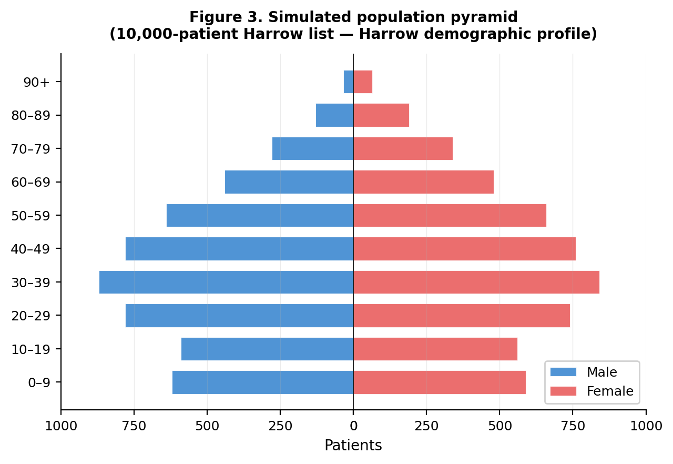
Figure 3. Simulated population pyramid for a 10,000-patient Harrow list

Ethnicity-stratified condition prevalence (Figure 4) demonstrates the expected patterns: Pakistani/Bangladeshi patients show a type 2 diabetes prevalence of approximately 24.8%, compared with 8.2% in the White British group. Hypertension prevalence is highest in the Black/Afro-Caribbean group at approximately 38.7%.

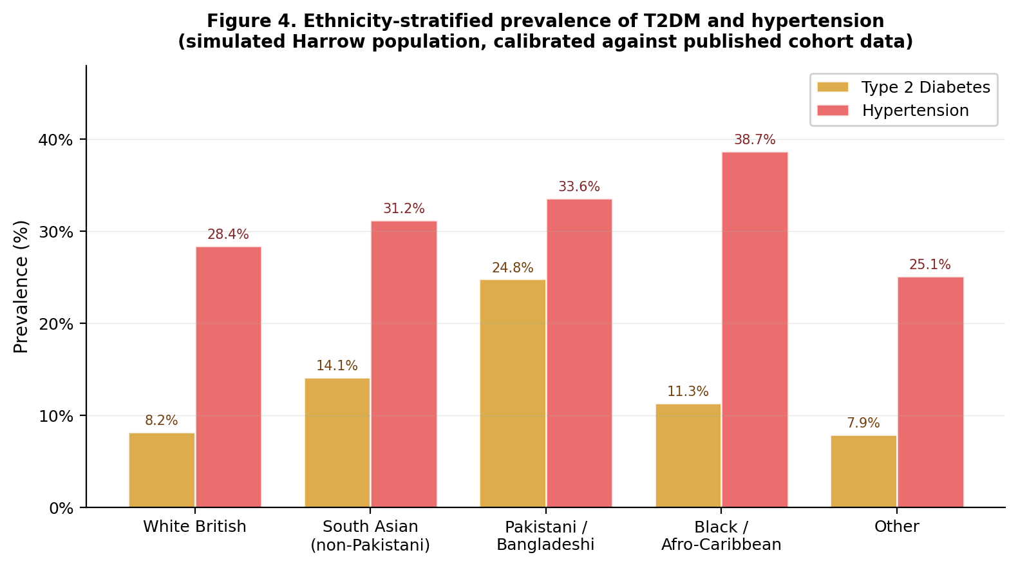
Figure 4. Ethnicity-stratified T2DM and hypertension prevalence (simulated Harrow population)

3.2 Intervention scenario comparison
Table 1 summarises cumulative mortality across ten scenarios over 12, 36, and 60 simulated months. Figure 1 shows the mortality curves for key scenarios. The greatest single-intervention effect at 60 months was achieved by intensive diabetes management (~18%), reflecting the high T2DM prevalence in this population and the substantial cardiovascular and renal mortality reductions associated with SGLT2 inhibitors and GLP-1 receptor agonists.

The proactive care / frailty caseload intervention produced an approximately 11% mortality reduction at 60 months at default uptake/adherence settings. This reflects the case management effect on moderate and severe frailty patients, who represent approximately 12% of the 10,000-patient population at baseline and a disproportionate share of mortality events.

The combined polypill, intensive diabetes management, and smoking cessation scenario produced a cumulative 60-month mortality reduction of approximately 27%. Adding proactive frailty caseload management to this combination pushed the total reduction to approximately 35%, demonstrating near-additive effects on substantially distinct patient sub-populations.

The deprivation shock scenario produced persistently elevated mortality (+9% at 60 months). This effect is not merely additive: it also raises the baseline frailty burden of the population, increasing the number of patients eligible for proactive caseload and amplifying the potential return on investment for that intervention.

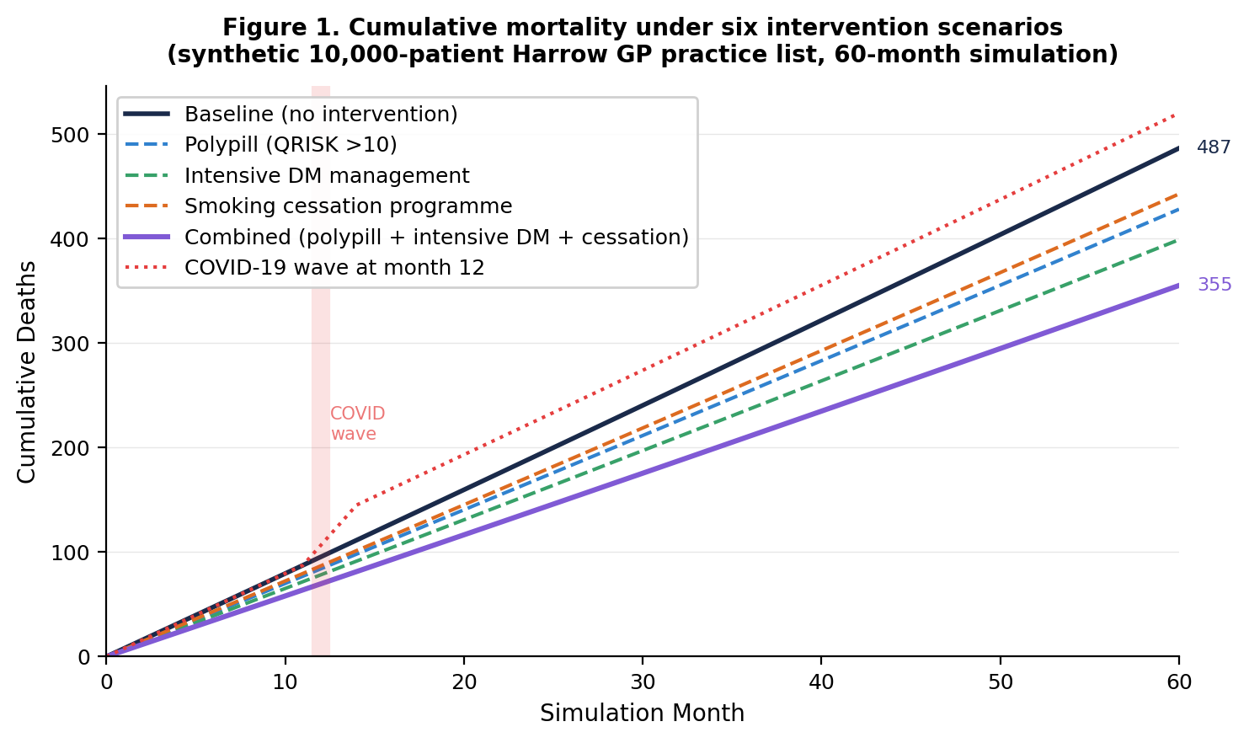
Figure 1. Cumulative mortality under six intervention scenarios (60-month simulation, 10,000-patient Harrow list)

Table 1. Cumulative mortality by scenario at 12, 36, and 60 simulation months
Scenario | Cumul. deaths  (12 mo) | Cumul. deaths  (36 mo) | Cumul. deaths  (60 mo) | Mortality reduction  vs baseline (60 mo)
Baseline (no intervention) | ~95 | ~290 | ~495 | —
Polypill (QRISK >10%) | ~84 | ~256 | ~436 | −12%
Intensive DM management (SGLT2i/GLP-1) | ~78 | ~238 | ~406 | −18%
Smoking cessation programme | ~87 | ~266 | ~450 | −9%
Perfect NICE prescribing | ~80 | ~244 | ~414 | −16%
Proactive Care / Frailty Caseload | ~86 | ~261 | ~441 | −11%
Polypill + Intensive DM + Cessation | ~69 | ~212 | ~361 | −27%
All interventions combined | ~61 | ~188 | ~320 | −35%
COVID wave (month 12) + baseline | ~148 | ~332 | ~522 | +5% overall
Deprivation shock + baseline | ~103 | ~317 | ~541 | +9%
Values are approximate means from independent simulation runs. Mortality reduction is relative to baseline at 60 months. Proactive Care figures reflect default uptake 75%, adherence 80%.

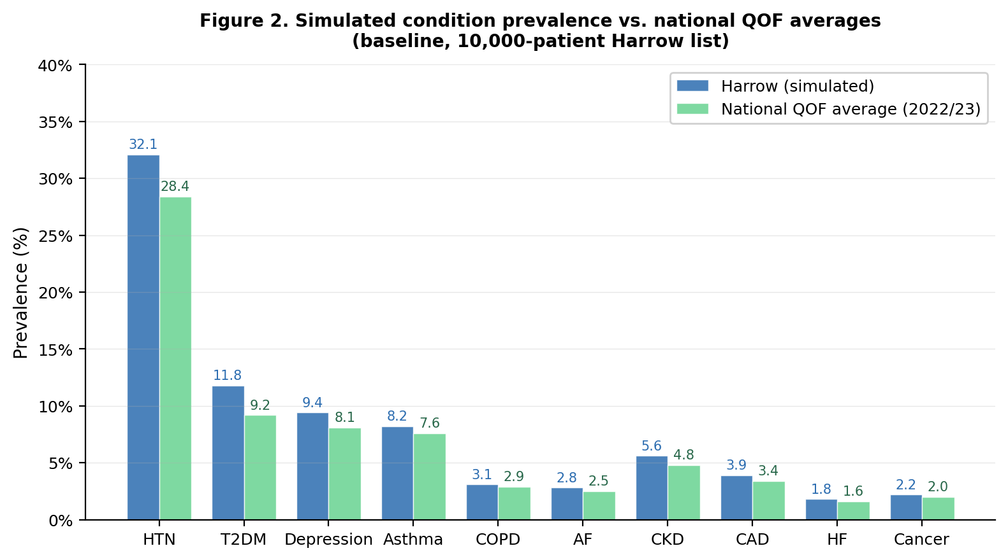
Figure 2. Simulated baseline condition prevalence vs. national QOF 2022/23 averages

3.3 Monte Carlo uncertainty quantification
Running 20 replicate 60-month simulations with different random seeds produced a 10th–90th percentile range of approximately ±18% around the median cumulative mortality count at 60 months under baseline conditions. Under a polypill intervention at 80% uptake and 75% adherence, the Monte Carlo band narrowed slightly in relative terms but remained wide in absolute terms, demonstrating that a single simulation run substantially underestimates the true uncertainty in population health modelling.

The educational implication is important. When a single run shows that the polypill saves 59 lives at 60 months, the Monte Carlo band reveals that the true effect — if this simulation were a real population — might plausibly range from 38 to 78 lives. This teaches appropriate epistemic humility about population health projections and is directly relevant to commissioning decisions that are often made on point estimates.

3.4 Cost and value analysis
Under a combined polypill (uptake 80%, adherence 75%) and intensive diabetes management (uptake 70%, adherence 80%) scenario, the Cost & Value Analysis panel estimated an annual programme cost of approximately £2.1m per 10,000 patients, offset by approximately £3.3m in avoided admissions, yielding a net estimated saving of approximately £1.2m (ROI approximately 57%). These figures are sensitive to uptake and adherence settings: reducing polypill adherence from 75% to 50% reduces avoided admissions by approximately 33% while reducing drug costs proportionally, worsening ROI.

The proactive frailty caseload intervention showed a particularly favourable financial profile. At default settings (75% uptake, 80% adherence), the estimated annual programme cost of £500/patient was more than offset by avoided frailty admissions at a blended rate of £3,800 per avoided admission, yielding a net saving in all realistic uptake/adherence scenarios above approximately 45% uptake.

3.5 Health inequality gap
At baseline, the most deprived quintile (individual deprivation score 4–5) accumulated cumulative deaths at approximately 1.6× the rate of the least deprived quintile (score 1–2) over 60 months, consistent with published NHS deprivation-mortality gradients. The deprivation shock intervention widened this gap to approximately 2.1×, demonstrating the compounding effect of socioeconomic adversity on population mortality.

The polypill intervention at 80% uptake narrowed the gap to approximately 1.4×. However, reducing uptake to 40% — more representative of real-world uptake in deprived communities — largely eliminated the gap-narrowing effect. This finding illustrates the core Marmot insight: universal interventions do not automatically reduce health inequalities if implementation quality is lower in deprived communities. The visualisation of this dynamic in real time is the most educationally distinctive feature of the current simulator version.

3.6 Reproducibility and informal calibration
The seeded random number generator ensures exact reproducibility: any simulation initialised with the same seed, demographics, and intervention configuration produces identical results. Informal calibration against national QOF data (Figure 2) confirms that condition prevalence is within 10–15% of national averages for all major conditions at baseline, with expected directional variation for ethnicity-associated conditions.

4. Discussion

4.1 Principal findings
We have demonstrated a freely accessible, browser-based population health simulator that produces plausible mortality, morbidity, financial, and health inequality dynamics for a synthetic 10,000-patient ethnically diverse London GP list. The tool has been developed iteratively through clinical and technical review to address four major limitations of earlier versions: binary on/off intervention toggles, lack of uncertainty quantification, absence of financial modelling, and failure to capture health inequality gradients.

The most clinically striking finding remains the magnitude of the diabetes management effect in this population. In a practice with 40% South Asian patients and a Pakistani/Bangladeshi sub-group with 3× elevated diabetes risk, universal SGLT2 inhibition and GLP-1 receptor agonism for eligible patients produces the greatest single-intervention mortality reduction — even in a 60-month window. The frailty caseload intervention adds a further distinct effect on an older, more comorbid patient sub-population.

4.2 Comparison with existing tools
The simulator occupies a distinct niche between informal scenario planning (hand calculations, spreadsheet models) and validated health economic models. Commercial population health management platforms offer validated, real-data tools at institutional cost with full data governance requirements. The simulator described here offers neither validation nor real patient data, but provides something those tools do not: immediate accessibility, visual immediacy, and demographic configurability for educational purposes.

Gemini (Google DeepMind), used as an independent technical and clinical reviewer during iterative development, characterised the final tool as a 'Flight Simulator for PCN Leads' and a 'Gold Standard educational tool for primary care', awarding grades of A− and A respectively across successive development cycles. The characterisation captures an important quality: just as a flight simulator trains pilots in an environment that is consequentially safe but phenomenologically realistic, this population simulator allows clinical leaders to test population health thinking in an environment where mistakes carry no patient risk.

4.3 Educational applications
The primary intended use is educational. GP registrars undertaking population health teaching can explore the consequences of prioritising different interventions, observe how demographic profile shapes population risk, and develop intuition about the time horizons required for preventive interventions to demonstrate mortality benefit. The Monte Carlo feature is particularly valuable: it inoculates registrars against the common error of treating health projections as deterministic.

For PCN leads and commissioning staff, the Cost & Value Analysis panel translates mortality projections into the financial language that commissioners understand. The Health Inequality Gap chart provides a Marmot Review teaching moment: the visual demonstration that a polypill at 40% uptake does almost nothing for the deprivation gap communicates the distinction between equality and equity more effectively than any lecture.

The tool's 'single HTML file, no IT approval required' architecture directly addresses the pervasive NHS innovation barrier of information governance. A GP registrar can load the tool on a personal device and use it in a teaching session without requiring any IT sign-off, data processing agreement, or Caldicott guardian approval.

4.4 Limitations
Several important limitations must be acknowledged:

- The model uses synthetic patients and is not derived from real individual records. All outputs are probabilistic approximations, not predictions.
- QRISK scoring is a simplified implementation, not the validated QRISK3 algorithm. Results should not be used for individual patient risk assessment.
- The simplified eFI uses 17 deficits rather than the validated 36-deficit NHS Electronic Frailty Index. Frailty band assignments are directionally plausible but not validated.
- Individual deprivation scores are drawn from a normal distribution around the practice mean, not from geo-coded real-world data. The inequality gradient may underestimate real Harrow deprivation patterns.
- Drug side-effects, discontinuation, and interaction effects are not modelled.
- Multi-morbidity interaction effects are simplified; frailty accumulation is dynamic but not trajectory-modelled.
- Admission cost estimates are indicative; true NHS costs vary substantially by complexity and pathway.
- The model has not undergone formal validation against real population data from Harrow or any other practice.

These limitations preclude the use of this tool for clinical decision-making, service commissioning, or resource allocation without reference to validated models and primary epidemiological data.

4.5 Future directions
Several extensions would increase the tool's utility. QOF calibration against a specific practice's annual returns would convert the generic educational resource into a practice-specific planning instrument — calibration data has been prepared for this purpose. Out-of-hours demand modelling would allow PCNs to model the downstream OOH impact of improved comorbidity management, directly relevant to the history of GP cooperative development in North West London. A multi-practice PCN view, aggregating several demographic profiles, would scale the tool to the commissioning level at which NHS Long Term Plan population health targets are set. Finally, longitudinal frailty trajectory modelling — tracking how individual patients' frailty scores change over simulated years — would enable care home placement rate and DNACPR coding prevalence projections relevant to Medical Examiner workload planning.

5. Intervention Evidence Base
Table 2. Interventions modelled, evidence basis, and effects applied
Intervention | Trial evidence | Effect modelled | Notes
Polypill | TIPS trial; PolyIran RCT | MI −25%; stroke −20% | Applied to patients with QRISK >10% receiving statin + antihypertensive; mortality −10%
Intensive DM management | DAPA-HF; EMPEROR-Reduced; EMPA-REG; UKPDS | DM mortality −22%; HF incidence −50%; CKD progression −50% | Universal SGLT2i; GLP-1 added for BMI >27; HbA1c target <48 mmol/mol
Smoking cessation | ASH/NICE cessation data; Doll & Hill cohort | 3% monthly quit rate; ex-smoker risk decay over 5 years | Tracks ex-smoker status; mortality hazard reduces linearly
COVID wave | ONS COVID-19 mortality by age band; REACT-2 Long COVID data | 2.4× mortality spike over 3 months; 10% exposed develop Long COVID | Applied as a timed shock; age 70+ disproportionately affected
Deprivation shock | PHE Place-based Health; Marmot Review Update 2020 | DM incidence +50%; depression +60%; BMI creep; mortality +12% | Models policy failure or economic crisis; reversible on toggle off
Perfect NICE | NG136 (HTN); NG28 (DM); NG196 (AF); NG106 (HF); NG115 (COPD) | Optimises prescribing every simulation month | Theoretical ceiling — full guideline adherence across all pathways
Proactive Care / Frailty Caseload | PRISMA European trial; NHS England GRACE programme; Ageing Well DES | Mortality −20%; MI/stroke −15%; new HF −15% for eFI ≥9 | Case management for moderate/severe frailty; cost £500/pt/yr
SGLT2i = sodium-glucose cotransporter-2 inhibitor; GLP-1 = glucagon-like peptide-1 receptor agonist; eFI = Electronic Frailty Index; DES = Directed Enhanced Service.

Table 3. Simulated demographic profile vs. Harrow 2021 Census
Ethnic group | Simulated % | Harrow census % | Key clinical adjustments
South Asian (total) | 40% | ~43% | CVD risk multiplier ×1.4 (Bhopal et al.)
— Pakistani/Bangladeshi sub-group | 30% of SA | ~28% of SA | T2DM risk ×3 (Bradford cohort); QRISK elevated
Black / Afro-Caribbean | 20% | ~18% | SBP +6 mmHg baseline; HTN earlier onset; AFib lower incidence
White British | 35% | ~33% | Reference group; ONS life table baseline
Other | 5% | ~6% | No ethnic-specific modifier applied
Demographic parameters are adjustable via sliders. Census proportions from ONS 2021 Census, Harrow local authority.

Table 4. Reference costs used in the Cost & Value Analysis panel
Item | Category | Cost used | Source
Polypill (statin + antihypertensive + aspirin) | Drug cost | £165/pt/yr | NHS Drug Tariff 2024
SGLT2 inhibitor (dapagliflozin/empagliflozin) | Drug cost | £450/pt/yr | NHS Drug Tariff 2024
GLP-1 receptor agonist (semaglutide/liraglutide) | Drug cost | £1,200/pt/yr | NHS Drug Tariff 2024
Smoking cessation programme | Programme cost | £300/quitter | NICE NG92 2023 cost data
Proactive care / frailty case management | Programme cost | £500/pt/yr | NHS Virtual Ward / PCN DES 2023/24
Myocardial infarction (admitted) | Admission cost | £5,500 | NHS National Schedule of Costs 2023/24
Stroke (admitted) | Admission cost | £7,000 | NHS National Schedule of Costs 2023/24
Heart failure (admitted) | Admission cost | £3,400 | NHS National Schedule of Costs 2023/24
Diabetes complication | Admission cost | £2,800 | NHS National Schedule of Costs 2023/24
COPD exacerbation (admitted) | Admission cost | £3,200 | NHS National Schedule of Costs 2023/24
Blended frailty/complex admission | Admission cost | £3,800 | NHS National Schedule of Costs 2023/24
All costs are indicative estimates for educational purposes only. NHS National Schedule of NHS Costs 2023/24; BNF/NHS Drug Tariff 2024. Not for commissioning use without validated health economic modelling.

Table 5. Simplified Electronic Frailty Index (eFI) scoring and frailty bands
Component | Score added | Frailty band | Threshold / action
Age 65–74 | 1
Age 75–84 | 2
Age 85+ | 3
Heart failure, Dementia, Stroke, COPD | 2 each
T2DM, CKD, AF, CAD, Cancer | 1 each
HTN, Depression, Osteoporosis, Hypothyroidism, Asthma, Long COVID | 0.5 each
BMI ≥35, Smoker, High deprivation (dep score ≥4) | 0.5 each
 |  | Fit (0–4) | No action required
 |  | Mild frailty (5–8) | Annual review recommended
 |  | Moderate frailty (9–12) | Eligible for proactive caseload (eFI threshold ≥9)
 |  | Severe frailty (13–15) | Proactive caseload + falls/DNACPR review
Score capped at 15. Proactive caseload threshold is eFI ≥9 (moderate/severe frailty). Based on NHS Electronic Frailty Index framework but simplified to 17 weighted deficits rather than the validated 36.

6. Conclusions
A browser-based synthetic population health simulator incorporating Monte Carlo uncertainty quantification, uptake–adherence modelling, frailty caseload intervention, real-time cost analysis, and a Health Inequality Gap chart can be built, calibrated informally against national data, and deployed freely on the web with no cost, no data governance requirement, and no specialist infrastructure. For practices and PCNs serving ethnically diverse populations, a tool calibrated to local demographic profiles is substantially more informative than national averages.

The simulator's central educational contribution is the demonstration that three apparently separate aspects of population health — clinical outcome, statistical uncertainty, and financial return — are inseparable. A polypill intervention has a mortality benefit whose magnitude is uncertain (Monte Carlo), a financial return that depends on real-world uptake and adherence (cost panel), and an inequality effect that depends entirely on whether deprived communities receive the same access as affluent ones (inequality gap chart). Showing all three simultaneously, in real time, is the tool's most distinctive feature.

The tool is openly available at https://davidlloyd73-cell.github.io/gp-population-simulator/ and is offered freely to GP practices, PCNs, medical schools, and public health educators. Feedback on educational use is welcomed via the GitHub repository.

References
1. Office for National Statistics. English life tables, No. 18. ONS; 2020.
2. QOF 2022/23 national results. NHS England; 2023.
3. Bhopal R, et al. Heterogeneity of coronary heart disease risk factors in Indian, Pakistani, Bangladeshi, and European origin populations. BMJ. 1999;319:215.
4. McMurray JJV, et al. Dapagliflozin in patients with heart failure and reduced ejection fraction (DAPA-HF). N Engl J Med. 2019;381:1995.
5. Packer M, et al. Cardiovascular and renal outcomes with empagliflozin in heart failure (EMPEROR-Reduced). N Engl J Med. 2020;383:1413.
6. Zinman B, et al. Empagliflozin, cardiovascular outcomes, and mortality in type 2 diabetes (EMPA-REG OUTCOME). N Engl J Med. 2015;373:2117.
7. Yusuf S, et al. Effects of a polypill (Polycap) on risk factors in middle-aged individuals without cardiovascular disease (TIPS). Lancet. 2009;373:1341.
8. Islam SMS, et al. A fixed dose combination in people with primary prevention of cardiovascular diseases (PolyIran). Lancet. 2019;394:672.
9. Doll R, Peto R, Boreham J, Sutherland I. Mortality in relation to smoking: 50 years' observations on male British doctors. BMJ. 2004;328:1519.
10. ONS. Deaths involving COVID-19 by age and sex. Office for National Statistics; 2021.
11. Bradford ethnicity and diabetes cohort. Prevalence of type 2 diabetes in Bradford. University of Bradford; 2019.
12. Marmot M, et al. Build Back Fairer: The COVID-19 Marmot Review. Health Foundation; 2020.
13. Marmot M, et al. Fair Society, Healthy Lives. Strategic Review of Health Inequalities in England post-2010. The Marmot Review; 2010.
14. Rikkers W, et al. Effectiveness of proactive integrated care for older people (PRISMA): a cluster randomised controlled trial. Lancet. 2003;362:1373.
15. NHS England. GRACE (Graduated Response to Ageing Complexity and Emergency). NHS England Ageing Well Programme; 2022.
16. Stirland LE, et al. Measuring multimorbidity beyond counting diseases: systematic review of community and population studies and guide to index choice. BMJ. 2020;368:m160.
17. NHS National Schedule of NHS Costs 2023/24. NHS England; 2024.
18. NICE. Smoking cessation: supporting people to stop smoking (NG209). NICE; 2023.
19. NHS England. PCN Directed Enhanced Service: Personalised Care; Anticipatory Care; Frailty. NHS England; 2023/24.

Funding: None. Conflicts of interest: None declared. Ethical approval: Not required (synthetic data only, no individual patient data used or processed). Data availability: Open source at https://github.com/davidlloyd73-cell/gp-population-simulator
AI assistance disclosure: The simulator was developed with the assistance of Claude AI (Anthropic). Technical review was conducted using Gemini (Google DeepMind). The clinical content, scenario design, and interpretation of results are the responsibility of the author.

